

**Semester 1 Examination, 2012**

**Question/Answer Booklet**

**MATHEMATICS**

**3C/3D (Year 12)**

**Section Two:**

**Calculator-assumed**

Your name: **_____Solutions_____**

Please circle your teacher’s name: S Ebert T Hosking S Rowden

**Time allowed for this section**

Reading time before commencing work: ten minutes

Working time for paper: one hundred minutes

**Material required/recommended for this section**

***To be provided by the supervisor***

This Question/Answer booklet

Formula sheet (retained from Section One)

***To be provided by the candidate***

Standard items: pens, pencils, pencil sharpener, eraser, correction/tape fluid, ruler, highlighters

Special items: drawing instruments, templates, notes on two unfolded sheets of A4 paper, and up to three calculators satisfying the conditions set by the Curriculum Council for this course.

**Important note to candidates**

No other items may be used in this section of the examination. It is **your** responsibility to ensure that you do not have any unauthorised notes or other items of a non-personal nature in the examination room. If you have any unauthorised material with you, hand it to the supervisor **before** reading any further.

**Structure of this paper**

|  |  |  |  |  |
| --- | --- | --- | --- | --- |
| Section | Number of questions available | Number of questions to be answered | Working time (minutes) | Marks available |
| Section One:  Calculator-free | 8 | 8 | 50 | 50 |
| Section Two:  Calculator-assumed | 13 | 13 | 100 | 100 |
|  | | | | 150 |

**Instructions to candidates**

1. The rules for the conduct of Western Australian external examinations are detailed in the *Year 12 Information Handbook 2012*. Sitting this examination implies that you agree to abide by these rules.
2. Write your answers in the spaces provided in this Question/Answer Booklet. Spare pages are included at the end of this booklet. They can be used for planning your responses and/or as additional space if required to continue an answer.

* Planning: If you use the spare pages for planning, indicate this clearly at the

top of the page.

* Continuing an answer: If you need to use the space to continue an answer, in

the original answer space where the answer is continued, i.e. give the page

number. Fill in the number of the question(s) that you are continuing to

answer at the top of the page.

1. **Show all your working clearly**. Your working should be in sufficient detail to allow your answers to be checked readily and for marks to be awarded for reasoning. Incorrect answers given without supporting reasoning cannot be allocated any marks. For any question or part question worth more than two marks, valid working or justification is required to receive full marks. If you repeat an answer to any question, ensure that you cancel the answer you do not wish to have marked.
2. It is recommended that you **do not use pencil** except in diagrams.

Section Two: Calculator-assumed (100 Marks)

This section has**thirteen (****13)** questions. Answer **all** questions. Write your answers in the space provided.

Spare pages are included at the end of this booklet. They can be used for planning your responses and/or as additional space if required to continue an answer.

* Planning: If you use the spare pages for planning, indicate this clearly at the top of the page.
* Continuing an answer: If you need to use the space to continue an answer, indicate in the original answer space where the answer is continued, i.e. give the page number. Fill in the number of the question(s) that you are continuing to answer at the top of the page.

Working time for this section is 100 minutes.

Question 9 (4 marks)

Consider the function  where ***a*** and ***b*** are constants.

(a) Find an expression for the gradient of the curve.

[1]

|  |
| --- |
| **Solution** |
|  |
| **Specific behaviours** |
| ✓ correct expression |

(b) Given that the tangents at A(0, ***b***) and B(2, 5) are parallel, find the value of ***a*** and ***b***.

[3]

|  |
| --- |
| **Solution** |
|  |
| **Specific behaviours** |
| ✓ determines gradient at x = 0  ✓ uses gradient and x coordinate of B to determine a  ✓ determines b using point B and a. |

**Question 10 (13 marks)**

(a) The function *f*(*x*) is shown below with the areas given in square units for the shaded region.

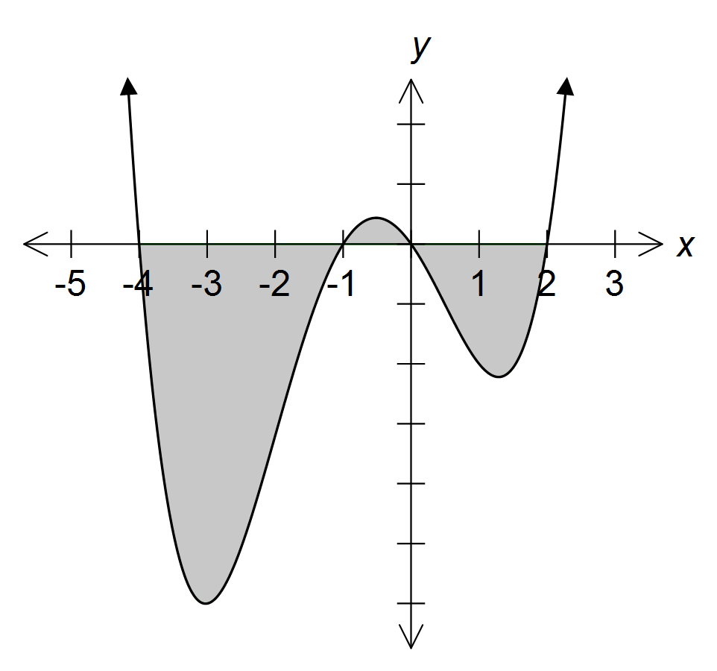

Area B = 2.9 units2

Area A = 105.3 units2

Area C = 27.2 units2

Determine the value of

(i)  [1]

|  |
| --- |
| **Solution** |
| -105.3 |
| **Specific behaviours** |
| ✓ correct answer |

(ii)  [2]

|  |
| --- |
| **Solution** |
| -105.3 + 2.9 + (-27.2)  =-129.6 |
| **Specific behaviours** |
| ✓ recognises +/- sections of function  ✓ correct answer |

(iii)  [3]

|  |
| --- |
| **Solution** |
|  |
| **Specific behaviours** |
| ✓ separates integral and relates to f(x)  ✓ calculates integral of each term  ✓ correct answer |

**Question 10 continued**

(b) (i) Sketch and  on the axes below.

[2]

|  |
| --- |
| **Solution** |
|  |
| **Specific behaviours** |
| ✓ correctly graphs  ✓ correctly graphs |

(ii) Find the intersection(s) between and .

[2]

|  |
| --- |
| **Solution** |
| (0, 0) and (16, 4) |
| **Specific behaviours** |
| ✓✓ identifies both points of intersections  ✓ only identifies one point of intersection |

(iii) *x* = *c* divides the region bounded between and into two regions of equal area. State an equation involving the use of calculus that represents the given situation.

Hence determine *c* to 1 decimal place.

[3]

|  |
| --- |
| **Solution** |
| C = 6.0 |
| **Specific behaviours** |
| ✓ identifies the use of definite integrals  ✓ determines appropriate equation involving the use of calculus and appropriate boundaries  ✓ correct solution |

Question 11 (12 marks)

A factory produces 2 types of Year 12 leavers’ jacket. The factory has enough cloth available to produce 1000 jackets per week. Jacket type A makes a profit of $30 while type B makes a profit of $45. The factory has a minimum weekly contract for 150 type A jackets and 200 of type B. Facilities for screen printing the jackets are limited to 30 hours per week. This equipment can screen print 60 per hour of type A and 20 per hour of type B.

Let A be the number produced per week of type A jacket and B be the number produced per week of type B jacket.

(a) Determine four inequalities from the information given. [3]

|  |
| --- |
| **Solution** |
|  |
| **Specific behaviours** |
| ✓ inequality involving 1000 jackets  ✓ inequalities on minimum weekly contract  ✓ inequality involving equipment that can screen print |

(b) Complete the graph below using your inequalities and shade the feasible region.

The line relating to the screen printing constraint has been given. [3]

|  |
| --- |
| **Solution** |
|  |
| **Specific behaviours** |
| ✓ graphs the inequality involving 1000 jackets  ✓ graphs the inequalities on minimum weekly contract  ✓ shades the feasible region |

**Question 11 continued**

(c) Determine how many of type A and B jackets the factory should produce per week to maximise the profit and state the maximum profit.

[3]

|  |
| --- |
| **Solution** |
| |  |  | | --- | --- | | (A, B) | P = 30A + 45B | | (200, 200) | 15 000 | | (800, 200) | 33 000 | | (600, 400) | 36 000 | | (150, 550) | 29 250 |   ∴ 600 A and 400 B |
| **Specific behaviours** |
| ✓✓ calculates profit on all critical points  ✓states the correct type of A and B jackets |

(d) By what percentage can the profit on jacket A change by before the solution in part (c) is no longer unique.

[3]

|  |
| --- |
| **Solution** |
| *k*1 = 45 or *k*2 = 15  Increase or decrease by 50% |
| **Specific behaviours** |
| ✓ identifies values of k  ✓ states increase of 50%  ✓ states decrease of 50% |

**Question 12 (7 marks)**

Each of the dots in the diagram below can be used to represent a vertex of a triangle.

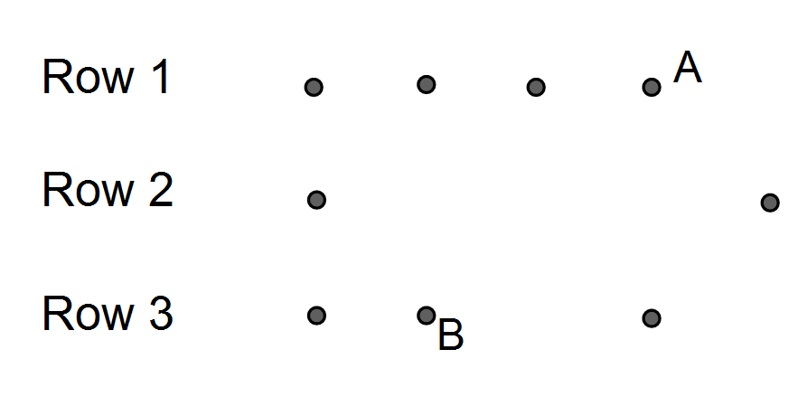

(a) How many triangles can be formed

(i) using dots from Row 1 and Row 2? [2]

|  |
| --- |
| **Solution** |
|  |
| **Specific behaviours** |
| ✓ selects 1 vertex from Row 1 and 2 from Row 2 and vice versa  ✓ correct solution |

(ii) if each vertex must come from a different row? [2]

|  |
| --- |
| **Solution** |
|  |
| **Specific behaviours** |
| ✓ selects 1 from each row and removes 3 points that don’t form a triangle  ✓ correct solution |

(b) If each triangle formed can only come from two rows at a time what is the probability

that a randomly selected triangle has dot A as one vertex of the triangle given that B

is also a vertex of the triangle?

[3]

|  |
| --- |
| **Solution** |
|  |
| **Specific behaviours** |
| ✓ identifies conditional probability  ✓ correct numerator  ✓ correct denominator |

Question 13 (6 marks)

In the first five seconds of inflation, the relationship between the radius (*r* cm) and time

(*t* sec) of a spherical party balloon are related by the formula:



(a) Show that the relationship between volume (*V* cm3) and time is given by [1]

|  |
| --- |
| **Solution** |
|  |
| **Specific behaviours** |
| ✓ substitutes r in terms of t into formula for volume of a sphere and simplifies |

(b) Determine the exact volume of the balloon 3 seconds after first being inflated. [1]

|  |
| --- |
| **Solution** |
|  |
| **Specific behaviours** |
| ✓ correct volume |

(c) Determine the rate the volume is changing when *t* = 2 seconds. [1]

|  |
| --- |
| **Solution** |
| V’(2) = 19301.95 cm3/s |
| **Specific behaviours** |
| ✓ correct answer |

(d) Determine the approximate change using the increments formula in volume as *t* increases from 3 to 3.01 sec. [3]

|  |
| --- |
| **Solution** |
|  |
| **Specific behaviours** |
| ✓determines derivative of V  ✓ substitutes t = 3 and δt into increments formula  ✓ correct approximate change |

Question 14 (10 marks)

A worker in the city finishes work at 5:30 pm and drives home. Depending on the conditions he drives home with no lights on or the parking lights on or the headlights on. If fact, for 80% of his journeys home he turns on no lights, for 5% of his journey he only turns on his parking lights, but for the rest, he turns his headlights on. If he uses his parking lights there is a 0.5 chance that he will leave them on overnight. This is certain to flatten his battery. If he uses the headlights there is only a 2% chance that he will leave them on overnight. If he leaves either of the lights on overnight the battery will flat in the morning.

(a) Draw a probability tree diagram to represent the given information.

[2]

|  |
| --- |
| **Solution** |
|  |
| **Specific behaviours** |
| ✓ correct 1st branch  ✓ correct 2nd branch |

(b) What is the probability that on the next journey home from work he uses his lights

and turns them off?

[2]

|  |
| --- |
| **Solution** |
| 0.05 × 0.5 + 0.15 × 0.98 = 0.172 |
| **Specific behaviours** |
| ✓ identifies either parking or head lights  ✓ correct answer |

**Question 14 continued**

(c) Because he left his lights on, he had a flat battery on Tuesday morning what is the

probability that on Monday night he left his parking lights on?

[3]

|  |
| --- |
| **Solution** |
|  |
| **Specific behaviours** |
| ✓ identifies denominator  ✓ identifies numerator  ✓ correct answer |

(d) The driver decided that, in future, whenever he turned on his lights to drive home it

would be his headlights on full. Would this decision reduce the chance of a flat battery? If so, by what factor?

[3]

|  |
| --- |
| **Solution** |
| 0.2 × 0.02 = 0.004  0.28 ÷ 0.04 = 7  Yes by a factor of 7 |
| **Specific behaviours** |
| ✓ calculates adjusted probability  ✓ Identifies it does reduce the chance of a flat battery  ✓ correct factor |

Question 15 (6 marks)

Two competing cyclist are riding with constant speed. At 12 midday cyclist X is 40 metres north of a judge and is riding east at 9m/s, while cyclist Y is 70 metres east of the judge and is riding north at 7m/s.

(a) Show diagrammatically this situation (a scale diagram is not required).

[1]

|  |
| --- |
| **Solution** |
|  |
| **Specific behaviours** |
| ✓ appropriate diagram |

(b) If the distance between the cyclist ***t*** seconds later is **D** metres, show that

**D**2 = 6500 −1820***t*** + 130***t***2

[2]

|  |
| --- |
| **Solution** |
|  |
| **Specific behaviours** |
| ✓ use of Pythagras thereom to determine distance  ✓ simplifies to show required equation |

(c) Determine the time the cyclists are closest together and determine the minimum

distance between them.

[3]

|  |
| --- |
| **Solution** |
| Time = 7 seconds and distance = 11.4 |
| **Specific behaviours** |
| ✓ Determine equation for D  ✓ correct minumum time (either use of CAS or derive and solve = 0)  ✓ correct distance |

Question 16 (8 marks)

A particle is moving under rectilinear motion with velocity  m/s*.*  Answer the following questions for the movement of the particle over the time interval .

(a) If the particle was initially 2 m to the right of the origin, what is the displacement from

the origin after 2 seconds? [2]

|  |
| --- |
| **Solution** |
|  |
| **Specific behaviours** |
| ✓ determines displacement equation  ✓ determines displacement at time = 2 |

(b) How far did the particle travel in the first 2 seconds? [2]

|  |
| --- |
| **Solution** |
|  |
| **Specific behaviours** |
| ✓ Use of CAS calculator and absolute value to determine distance  ✓ corrrect distance |

(c) What was the average speed during the 5th second? [2]

|  |
| --- |
| **Solution** |
|  |
| **Specific behaviours** |
| ✓ calculates displacement at t = 4 and t = 5  ✓ determines average speed |

(d) For what subset(s) of the given time interval is the acceleration negative? [2]

|  |
| --- |
| **Solution** |
|  |
| **Specific behaviours** |
| ✓ solves for a(t) < 0  ✓ correct interval |

Question 17 (8 marks)

The graph of  is shown.



(a) Use the second derivative to show that a possible point of inflection exists at 

. [2]

|  |
| --- |
| **Solution** |
|  |
| **Specific behaviours** |
| ✓ determines the second derivative  ✓ solves the y’’=0 |

(b) Use a sign test to verify that the point where  is, in fact, a point of inflection.[2]

|  |
| --- |
| **Solution** |
| |  |  |  |  | | --- | --- | --- | --- | | x |  |  |  | | y' | -ve | 0 | -ve | |
| **Specific behaviours** |
| ✓ tests to y’ to left and right of y’=0  ✓ results demonstrate y’ is same either side |

**Question 17 continued**

(c) Calculate the equation of the tangent to the curve drawn at the point of inflection.

[2]

|  |
| --- |
| **Solution** |
|  |
| **Specific behaviours** |
| ✓ correct gradient  ✓ correct y-intercept |

(d) A conjecture is made that a tangent drawn through a point of inflection will go through at least one turning point. Use a counter−example to show that this conjecture is false.

[2]

|  |
| --- |
| **Solution** |
| Turning points    Neither point lies on the line |
| **Specific behaviours** |
| ✓ Determines at least one turning point  ✓ shows the point(s) don’t line on the line |

**Question 18 (8 marks)**

X and Y are two events where 3P(X) = 2P(Y) and P(X ∪ Y) = .

(a) If P(Y) = *p* determine the value of *p* given X and Y are mutually exclusive.

[2]

|  |
| --- |
| **Solution** |
|  |
| **Specific behaviours** |
| ✓ Uses addtion principal  ✓ correct value of p |

(b) If P(Y) = 0.6 determine whether the events X and Y are independent.

[4]

|  |
| --- |
| **Solution** |
| ∴ X and Y are not independent. |
| **Specific behaviours** |
| ✓ determines P(X)  ✓ determines P(X∩Y)  ✓ tests for independence  ✓ states events are not independent |

(c) If P(Y) = *p* determine the value of *p* given X and Y are independent.

[2]

|  |
| --- |
| **Solution** |
|  |
| **Specific behaviours** |
| ✓ determines equation using addition principal  ✓ solves for p (needs to acknowledge 2 solutions to equation but p ≠ 2 for mark) |

**Question 19 (5 marks)**

(a) Use any method to determine the derivative of . [1]

|  |
| --- |
| **Solution** |
|  |
| **Specific behaviours** |
| ✓ correctly determines derivative |

The expression



is called the Newton quotient and is used to determine the derivative of a function.

(b) Use the Newton quotient to determine the derivative of . Simplify your answer. [2]

|  |
| --- |
| **Solution** |
|  |
| **Specific behaviours** |
| ✓ substitutes 1/x into expression  ✓ simplifies expression |

(c) If *h* is approaching 0, does your answer in (b) equal your answer in (a)? Explain. [2]

|  |
| --- |
| **Solution** |
| Yes as h → 0 the answer in (b) equals the answer in (a) |
| **Specific behaviours** |
| ✓ correct answer  ✓ explaination |

**Question 20 (7 marks)**

In the game of billiards, one of the scoring shots is a “cannon”. The player hits the white ball, W, with the cue and it cannons into one of the red balls, R1 or R2. The player’s objective is to sink a red ball in one of the pockets A, B, C or D.

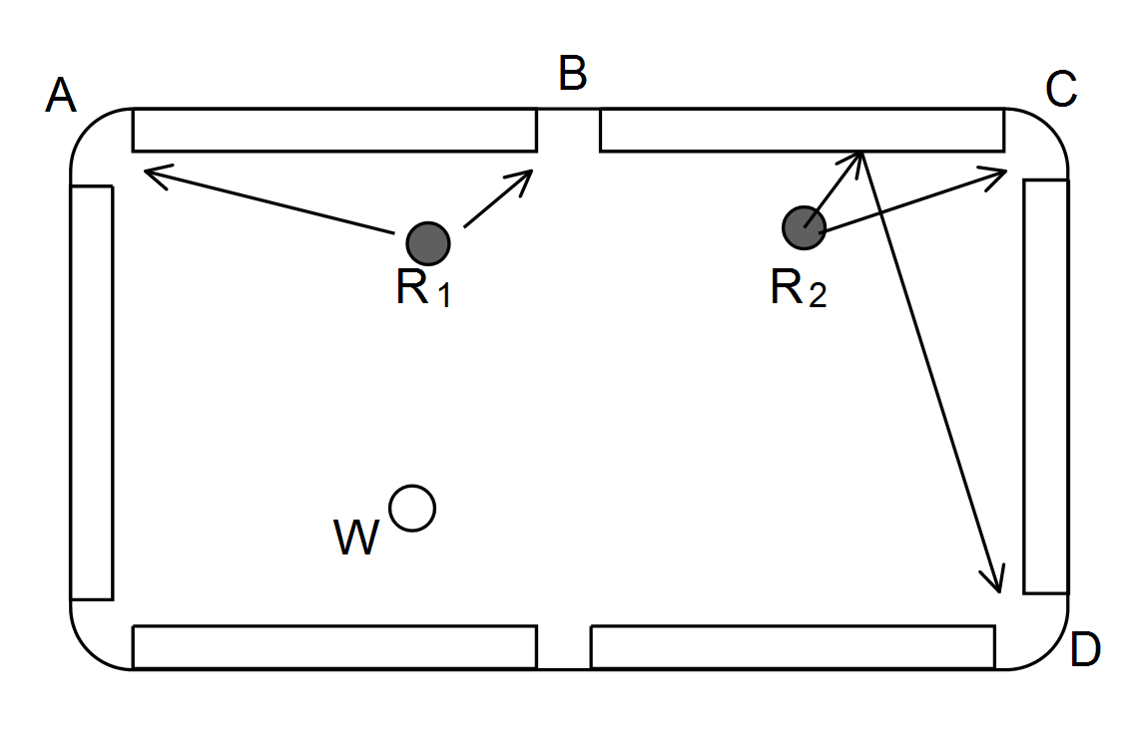

The player is about to attempt a cannon. She considers only the four pockets A, B, C or D for this shot as indicated on the diagram.

The probability that she will attempt the shots A, B, C or D is in the ratio 7 : 6 : 5 : 2.

(a) List these probabilities.

[1]

|  |
| --- |
| **Solution** |
|  |
| **Specific behaviours** |
| ✓ correct probabilities for A, B, C and D |

If she attempts one of these shots, the respective probabilities of sinking a red are:



Determine the probability that

(b) she will sink a red in B.

[1]

|  |
| --- |
| **Solution** |
|  |
| **Specific behaviours** |
| ✓ correct probabilities |

(c) she will not sink a red.

[2]

|  |
| --- |
| **Solution** |
|  |
| **Specific behaviours** |
| ✓ correct probabilities for A, B, C and D |

(d) she attempted shot D given she didn’t sink a red.

[3]

|  |
| --- |
| **Solution** |
|  |
| **Specific behaviours** |
| ✓ correct probabilities for A, B, C and D |

**Question 21 (6 marks)**

Given ,  and 

(a) Use composite function notation to describe:

(i) [1]

|  |
| --- |
| **Solution** |
|  |
| **Specific behaviours** |
| ✓ correct description |

(ii) *x* [1]

|  |
| --- |
| **Solution** |
|  |
| **Specific behaviours** |
| ✓ correct description |

(iii)  [1]

|  |
| --- |
| **Solution** |
|  |
| **Specific behaviours** |
| ✓ correct description |

(b) (i) Determine  [1]

|  |
| --- |
| **Solution** |
|  |
| **Specific behaviours** |
| ✓ determines correctly |

(ii) Determine the domain and range of  [2]

|  |
| --- |
| **Solution** |
|  |
| **Specific behaviours** |
| ✓ determines domain correctly  ✓ determines range correctly |